Assignment 1

1. Write a java program to find the area of rectangle
2. Write a java program to check the given no is Armstrong or not(153 is Armstrong no 1*1*1+5*5*5+3*3*3=153)
3. Write a java program to check the given no is palindrome or not
4. Write a java program to generate first N prime numbers
5. Write a java program to print even numbers in between given two numbers.

1. What is Abstraction?

2. What is Encapsulation?

3. What is JDK?

4. What is JVM?

5. Define Inheritance

6. How java achieved platform independence?

7. Write the syntax of main function.

8. What is conditional operator?

9. How many data types in java?

10. What is constant? How it is declared?

**ANSWERS**

2)

import java.util.*;

public class Armstrong

{

public static void main(String[] args){

Scanner sc = new Scanner(System.in);

int n=sc.nextInt();

int s=n;

int sum=0;

while(n>0){

int r=n%10;

sum=sum+(r*r*r);

n/=10;

}

if(s==sum){

System.out.println(s+" "+"is a Armstrong number");

}

else{

System.out.println(s+" "+"is not a Armstrong number");

}

}

}

Output:

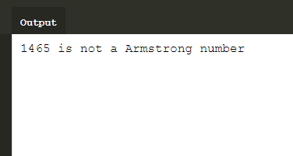

1)

import java.util.*;

public class Program

{

public static void main(String[] args) {

Scanner sc=new Scanner(System.in);

int l=sc.nextInt();

int b=sc.nextInt();

System.out.println("The area of rectangle of length "+l+" breath "+b+": "+l*b);

}

}

Output:

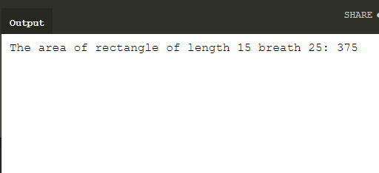

3)

import java.util.*;

public class Program

{

public static void main(String[] args) {

Scanner sc=new Scanner(System.in);

int n=sc.nextInt();

String s=String.valueOf(n);

StringBuilder sb=new StringBuilder(s);

sb=sb.reverse();

String m=sb.toString();

if(m==s){

System.out.println(n+" "+"is a palindrome number");

}

else{

System.out.println(n+" "+"is not a palindrome number");

}

}

}

Output:

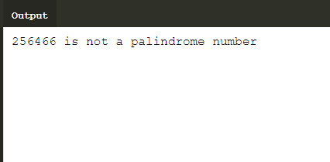

4)

import java.util.*;

public class Program

{

public static void main(String[] args) {

int num,i,j,flag=0;

Scanner sc=new Scanner(System.in);

num=sc.nextInt();

System.out.println("Prime numbers upto"+num+" is :");

for(i=2;i<num;i++)

{

flag=0;

for(j=2;j<=i/2;j++)

{

if(i%j==0)

{

flag++;

}

}

if(flag==0)

System.out.print(i+" ");

}

}

}

Output:

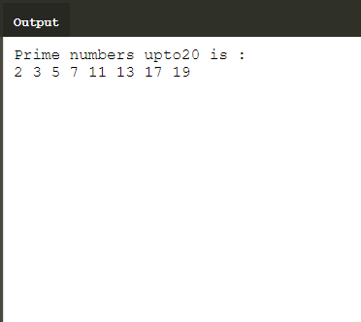

5)

import java.util.*;

public class Program

{

public static void main(String[] args) {

Scanner sc=new Scanner(System.in);

int first=sc.nextInt();

int last=sc.nextInt();

System.out.println("Even numbers between "+first+"and"+last+":");

for(int i=first;i<=last;i++){

if(i%2==0){

System.out.print(i+" ");

}

}

}

}

Output:

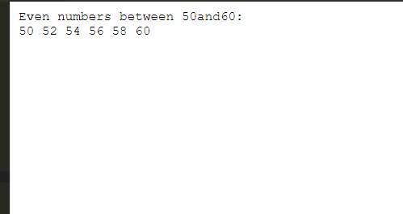

1. **Abstraction:** Data **abstraction** is the process of hiding certain details and showing only essential information to the user.
2. **Encapsulation:** Encapsulation is a mechanism of wrapping the data and code acting on the data together as a single unit. Declare the variables of a class as private.
3. **JDK** is a key platform component for building java application.
4. **Java virtual machine** is a engine that provide runtime environment to drive the java code or application.It converts java bytecode into machine language.JVM is a part of java run environment.
5. **Inheritance** is a mechanism in which one object acquires all properties and behaviors of a parent object.In inheritance we create new classes that are built upon existing classes.when you inherit from an existing class, you can reuse method and fields of parent class.
6. In java while we run java code in JVM we have byte code ,byte code can run on any platform.key is byte code is not machine instruction they are platform independent instructions to JVM.In final the combination of byte code and JVM makes java program platform independent.
7. The Syntax of main function is

**Public class program**

**{**

**Public static void main(Strings[] args)**

**{**

**}**

**}**

1. The conditional operator is a ternary operator and it is used to evaluate Boolean expressions .
2. Data types are divided into two groups,

1.Primitive data type-byte,int,short,long,float,double,Boolean and char

2.Non-primitive data types-String,classes,Arrays.

10)A constant is a variable whose value cannot change once it has been java doesn’t have built in support for constants.

We used FINAL keyword to declare the constant variable

SYNTAX: final float pi=3.14f;